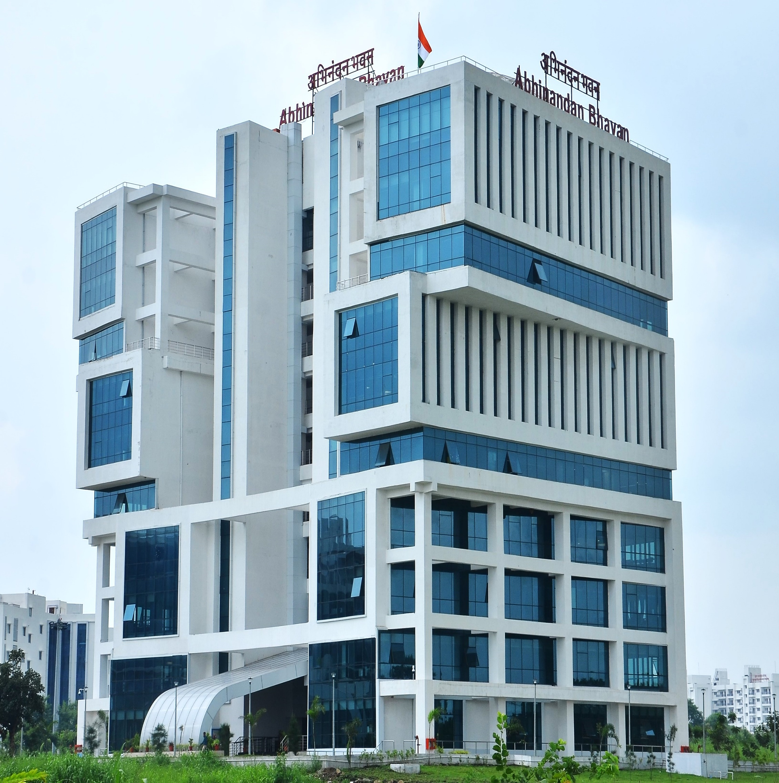
Advertisement for Admission to Ph.D. Program in Department of Physics, IIT Indore
Adv. No.: IITI/Phy/Ph.D. Admission/2025/04
Submission Deadline: 31st October, 2025
Written test and offline interviews of Shortlisted candidates: November 11th & 12th, 2025
For Eligibility Qualifications, Directions and Application Process see bottom

About the Department of Physics:
The Department of Physics has been a vibrant and flourishing department since the inception of the Institute in 2009. Presently the department consists of 19 faculty members with expertise in diverse fields such as condensed matter physics, high energy physics, black-hole physics, gauge/gravity duality and complex networks. Our research labs have state-of-the-art facilities, that have grown and evolved over the years to facilitate cutting-edge research and foster innovation and technology development amongst the young research students.

Our PhD students have been placed at prestigious institutes worldwide and are actively pursuing research. Our commitment to providing students with practical research experience extends across all levels of education, from undergraduate to postgraduate programs. To this end, the department has established more than 15 advanced research laboratories, each focusing on different branches of physics, to provide our students with unique research opportunities and an exceptional learning experience.

The Department of Physics at IIT Indore proudly showcases a diverse range of cutting-edge research areas, which can be broadly categorized into three primary subgroups: Condensed Matter Physics, High Energy Physics, and Complex Networks and Systems (Further details appear in the subsequent pages). The department prides itself on fostering a highly collaborative research environment, that facilitates close interaction across various departments in IIT Indore, and renowned national and international institutions. Presently we have active collaboration with IISc Bangalore, TIFR, IITs (Bombay, Delhi, Madras, Kanpur, Ropar, Hyderabad, Bhilai), RRCAT, Indore, BARC, Mumbai, IISERs (Kolkata, Pune, Behrampur), NISER, CRL-Ooty, HRI Allahabad, Central Universities (Pune, Mumbai, Allahabad, Calcutta), SNB-NCBS, Kolkata, and SINP – Kolkata.

Our international collaborations include but are not limited to the University of Cambridge, University of Oxford, Stanford University, Michigan State University-USA, Penn State University-USA, CUNY-USA, LUH Hannover-Germany, Rutherford Appleton Laboratory and ISIS Facilities - UK, TU Berlin - Germany, TU Dortmund - Germany, Queens Marry University London-UK, LMU-Munich, Germany, Bern University-Switzerland, Osaka University- Japan, NTU - Singapore, Complexity Science Institute - CNRS Italy, Instituto Superior Tecnico, Lisbon, Portugal, CERN, Switzerland, GSI, Darmstadt, Germany, Wigner Research Centre, Budapest.

Invitation of admission to the Ph.D. Program in the following research areas:

Research Area | Faculty Members
Condensed Matter Physics (Experimental) | - Prof. Preeti A. Bhobe  - Prof. Krushna R. Mavani  - Prof. Rajesh Kumar  - Prof. Sudeshna Chattopadhyay  - Prof. Pankaj R. Sagdeo  - Prof. Somaditya Sen  - Dr. Onkar S. Game  - Dr. Naresh K. Kumawat  - Dr. Bivas Dutta
Condensed Matter Physics (Theory and Computation) | - Dr. Srimanta Pakhira  - Dr. Alestin Mawrie
High Energy Physics (Experimental) | - Prof. Raghunath Sahoo  - Prof. Ankhi Roy
High Energy Physics and Particle Physics (Theory) | - Prof. Subhendu Rakshit  - Dr. Manvendra Mahato  - Dr. Dipankar Das  - Dr. Debajyoti Sarkar  - Dr. Mritunjay Kumar Verma
Nonlinear Dynamics and Complex Systems (Networks, Statistical Physics, Nonlinear Dynamics, Computational Biology) | - Prof. Sarika Jalan

BRIEF AREAS OF RESEARCH OF INDIVIDUAL FACULTY MEMBERS are provided below
(details can be found from personal webpages):

Faculty Member | Research Area | Website | Email
Condensed Matter Physics (Experimental)
Prof. Preeti A. Bhobe | Unconventional Magnetism in quantum materials, Magneto-transport in 2D and Spintronic materials, Magnetocaloric effect, X-ray Absorption Fine Structure, Photoemission Spectroscopy, Neutron Diffraction. | Website | pbhobe@iiti.ac.in
Prof. Krushna R. Mavani | Terahertz spectroscopy of solid materials, Pulsed Laser Deposited nanostructures, thin films and multilayers, Phase-transitions, Electronic and magnetic properties, Structure-property relations, Optoelectronic materials and devices. | Website | krushna@iiti.ac.in
Prof. Rajesh Kumar | Nanomaterials & nanodevices, electronic and electrochromic devices, Device physics, Raman Spectroscopy & Microscopy, Natural Biomaterials | Website | rajeshkumar@iiti.ac.in
Prof. Sudeshna Chattopadhyay | Surface and Interface science, Nano and 2D-materials, Thin films, Quantum materials; Energy conversion and Energy storage: Batteries (Li and Al-ion batteries) and Supercapacitors; Nano-devices, Nanotechnology in disease diagnosis and Environmental remediation; Soft matter physics; Organic/inorganic-heterojunction; Structure-Property Correlations: optical/electronic properties; X-ray scattering (XRR, GISAXS, GID, XRD), Spectroscopy, Atomic Layer Deposition (ALD). | Website | sudeshna@iiti.ac.in
Prof. Pankaj R. Sagdeo | Physics of Semiconductors, Nanomaterials, Materials for Solar cell and Energy applications, Photovoltaics, Magnetic and ferroelectric, magneto-dielectric and optoelectronic materials, Physics of Crystallographic and related phase transition/structure property correlations across phase transition, Superconductivity, Electron-Phonon Physics, Thin-films, multilayers, Raman and Optical spectroscopy etc. | Website  Website | prs@iiti.ac.in
Prof. Somaditya Sen | Structure-Correlated Physical Property Studies on the following fields:  1. Dielectric Resonator Antennas: Studies of designing Antennas using Oxide Ceramics to cater to different bands especially in the GHz and THz range  2. Ferroelectric, Magnetoelectric, Piezoelectric Materials: Studies on Polarization, Energy Storage Efficiency, Phase Transitions, Morphotropic Phase Boundaries, Piezo-photonics, Transport/Dielectric/Polaronic Properties  3. Oxide Thin Films: Device Studies  4. Green Synthesized Oxide Nano-Materials: Studies on Functionalization of Nanoparticles, Effect and Mechanism on Antibacterial, Wound Healing and Seed Germination Properties  5. Modified Simple Oxides: Studies on Light-Sensing, Gas-Sensing, Device Fabrication  6. Green synthesis of Nano-Materials for biological applications. | Website | sens@iiti.ac.in
Dr. Onkar S. Game | We work in the realm of novel semiconductor nanostructures and thin films for energy (Solar Cell, Solar-fuel etc.) and optoelectronic applications (LEDs, photosensors, transistors etc.). Specifically, we use nanostructures and thin films of semiconductors such as metal oxides, organic-inorganic hybrid halide perovskites, organic semiconductors etc. for renewable energy generation using Solar Cells and/or Solar Fuel (H2 generation by solar-water splitting/ Solar-CO2 reduction etc). We aim to gain thorough understanding of underlying device physics and hence improve the performance/efficiency of such energy and optoelectronic devices. For this we use range of material and device characterization tools (XRD, UV, SEM, Raman, PL, XPS, IV-measurements, electrochemical JV/impedance analysis etc.) | Website | ogame@iiti.ac.in
Dr. Naresh K. Kumawat | Metal Halide Perovskite (MHP) and Organic Semiconductors, Organic-inorganic perovskite semiconductors and solar cells; Fabrication, Light Emitting Diodes (PeLEDs) and Solar Cells; Device Characteristics; Device Physics | Website | nkumawat@iiti.ac.in
Dr. Bivas Dutta | Cryogenic-Temperature Quantum Transport Lab: Quantum heat transport and thermodynamics; Nano-electronic quantum devices: Quantum-Dots, Superconducting tunnel junctions; Quantum Hall thermal transport in 2D materials; Employing non-abelian Majorana edge modes in the Topological Quantum Computations. | Website  Website | bivas@iiti.ac.in
Condensed Matter Physics (Theory and Computation)
Dr. Alestin Mawrie | (Nanoscale and Mesoscale physics): Topological Insulators, Topological Spintronics, Dirac materials, Quantum Transport properties. | Website | amawrie@iiti.ac.in
Dr. Srimanta Pakhira | Condensed Matter Theory, Computational Materials Physics and Materials Science, Condensed Matter Nanoscience, Electronic Structure Theory, Density Functional Theory and Molecular Dynamics (MD) Simulations, Semiconductor Physics, Magnetism, Physics of Novel Solar Cells and Perovskite, Renewable Energy Technology. Porous Materials and Their Applications in Gas Storage, Separation, Adsorption and Drug Delivery in Metal-Organic Frameworks and Covalent Organic Frameworks. Alkali-ion Battery, Novel Batteries Technology, Renewable Energy Materials, Carbon Capture, Graphene, Bilayer Graphene, Mxene, Electrocatalysts, Photocatalysts, Novel 2D Materials, H2 & O2 Evolutions, and Alkane Cracking in Oil Refining Technology. | Website | spakhira@iiti.ac.in
High Energy Physics (Experimental)
Prof. Raghunath Sahoo | High-Energy Physics Experiment (ALICE Experiment @ CERN, Switzerland and CBM Experiment @ GSI, Germany), Phenomenology of Quark-Gluon Plasma, Exploration of QCD Phase Diagram, GRAPES-3 (Gamma Ray Astronomy PeV Energies); Applications of Statistical Mechanics and Machine Learning in High Energy Physics, Charmonia production dynamics at LHC energies, Event topology and multihadron production dynamics, Astroparticle Physics. | Website | raghunath@iiti.ac.in
Prof. Ankhi Roy | Heavy Flavor Hadrons, Heavy Ion Collision (Experiment: ALICE@LHC, CBM@FAIR), Study of Exotics with Electron Ion Collider (EIC)Experiment, Detector Simulation, Machine Learning, QGP Phenomenology | Website | ankhi@iiti.ac.in
High Energy Physics & Particle Physics (Theory)
Prof. Subhendu Rakshit | Astroparticle physics with dark matter and neutrinos, cosmology, experimental constraints on models beyond the standard model of particle physics, effective field theory and collider physics, gravitational waves, etc. | Website | rakshit@iiti.ac.in
Dr. Manavendra Mahato | Gauge/gravity correspondence, String Theory, General relativity. | Website | manav@iiti.ac.in
Dr. Dipankar Das | Particle Physics phenomenology, Phenomenology of the Higgs boson, Flavor Physics, Grand Unified Theories, Interplay between Neutrino mass and Dark matter. | Website | d.das@iiti.ac.in
Dr. Debajyoti Sarkar | Theory of quantum gravity (string theory), in particular Anti de Sitter (AdS)/ conformal field theory (CFT) correspondence. Connections between AdS/CFT and quantum information theory. Topics on semiclassical gravity and its applications in black hole physics and Hawking's information paradox. | Website | dsarkar@iiti.ac.in
Dr. Mritunjay Kumar Verma | String Theory, AdS/CFT correspondence, Flat space holography and quantum gravity, Higher spin fields, Low energy physics from string theory and machine learning, String field theory. | Website | mritunjay@iiti.ac.in
Non-Linear Dynamics And Complex Systems
Prof. Sarika Jalan | Synchronization, Hypergraphs, Machine learning, Power-grid networks, Financial networks, Tipping points, Time evolving networks, Chaos, Coupled Oscillators | Website | sarika@iiti.ac.in
Applications are invited from highly motivated and research-oriented applicants for admission to PhD Program in Physics. Applicants are advised to visit the profiles of the faculty members at the physics department web page (https://physics.iiti.ac.in/faculty/), and the advertisement, before applying for PhD Program.
Applicants are selected for admission to PhD program through a rigorous evaluation process which includes an interview by a selection committee and mere application does not imply admission into the PhD program.
Before deciding for paying a non-refundable application fee, please verify your eligibility by checking the MEQ and QE requirements.

Admission Categories:
FA (Fellowship Awardee): Fellowship Awardees from the funding agencies such as CSIR, UGC, NBHM, DST etc. The scholarship will be as per the rules of the concerned funding agency.
TA (Teaching Assistantship): Institute Teaching Assistantship with scholarship as per MHRD guidelines.
SW (Sponsored WITHOUT Institute scholarship): For applicants sponsored from a highly reputed R & D organization or Industry. [After completion of required course work, either on Full Time (SWF) or Part Time (SWP) basis, with approval of the competent authority] (Additional Rules)
IS (Institute Staff): Only for regular staff members of IIT Indore (on Part Time basis). (Additional Rules)
DF (Defense Forces): Serving personnel of defense forces WITHOUT any scholarship from the Institute. (Additional Rules)

CT (College Teacher): Permanent Employee of the sponsoring College/Institute/University WITHOUT any scholarship from the Institute.
Applicants under IS, DF, SW and CT categories are required to send following documents in original, along with a copy of application form to the Office of Dean, Academic Affairs. However, copies of these documents should also be sent or to be produced along with original application form as required by the Department.
- Form for Sponsorship letter for applicants under IS, SW and DF category
- Form for NOC for applicants under IS, SW and DF category
- Form for selecting a Co-Supervisor from an External or Sponsoring Organization (if required)
- Form for the employer for the candidates joining PG or PhD program on study leave under SW and DF category
- Form for No Objection-cum-Sponsoring-Experience Certificate from the Sponsoring University College Institution for PhD Applicant under CT category
For more details about admission category and eligibility, kindly refer to the main Ph.D. Advertisement of the Institute available at https://academic.iiti.ac.in/phdadvt.php.

- Minimum Educational Qualifications (MEQs) and Qualifying Examination (QE) for applicants:
- M.Sc./M.S./M.Tech. in Physics, Optoelectronics, Solid State Physics, Nanotechnology/Nano-sciences, Applied Physics or Mathematics or Applied Mathematics (with first division as
defined by the awarding Institute/University),
OR
- Four-year UG degree in Engineering Physics/Applied Physics
AND
- with a valid UGC-JRF/ CSIR-JRF, UGC-NET (LS, PhD), DST Inspire, GATE (in Physics/Mathematics), JEST (in Physics) or Equivalent Fellowship.

Applicants must keep in mind the following before applying:
- Applicant must visit the faculty profiles of the Department of Physics at https://physics.iiti.ac.in/faculty/
- The applicant must understand the research interest of individual faculty members of the department before appearing the interview according to his/her preference.
- At the time of the application, the applicant should have a very clear idea of the subject of research that he/she wants to pursue and should be able to convince the interview committee about the same.
- The application procedure is given at the end of this document.
- Descriptions on admission categories, eligibility, etc. can be found on the main page: http://academic.iiti.ac.in/phdadvt.php which needs to be read and understood in detail.
- If selected, the shortlisted applicant will be informed by email.

Application Procedure:
1. Candidates must apply ONLINE through the IIT Indore website. This will generate a unique application number for each applicant. The last date for online application is 31st October, 2025.

2. Application fee should be paid through State Bank Collect only. This will generate a payment code number that will be required while initiating the filling out of online application forms.

3. The shortlisted applicants will be intimated by email ONLY. Hence, please state your email id carefully. Please check your SPAM folder regularly.

4. The Shortlisted candidates should arrange for at least TWO recommendation letters to be submitted to us in the format provided. A separate email for the same will be sent by us in this regard to the short-listed candidates. Those who have already submitted the recommendation letters to us, DO NOT resend it.

5. The interview process consists of 2 stages. Shortlisted candidates will have to physically appear for a written test to be held in IIT Indore. Candidates passing this test will appear for interviews which will be held at IIT Indore. Candidates will be required to make their own travel arrangements and can opt for hostel accommodation. The tentative dates of the written test and interview are November 11th & 12th, 2025.

6. The candidates appearing for the interview will be asked for a handwritten ‘Statement of Purpose’, describing the details of their interest/motivation, their relevant learning, and skills in research as well as their reason for joining Ph.D. in Physics at IIT Indore.

7.The decision of the Institute in all matters will be final.

8. For any queries, please contact admission-phy@iiti.ac.in and/or phone 731-6603417.

